Go to http://www.techsmith.com/download/jing/ and download Jing.
There is a tutorial in the Resources area if you need help, although it is pretty simple to use.
Answer the questions in red. You will be submitting this file to the dropbox when you are done, including snapshots you will take with Jing.
Use ssh to log into your account. 134.197.153.140

Create a directory called module6. Change into that directory and put all the files you create in there.

Type the following to see just your process:
ps
How many do you have currently running?
What are they according to the command (CMD) that started that process?
What is the PID (process id) of your shell (bash)?

2 processes, bash, and ps.
The process ID of bash is 8376

Using redirection you can put that information into a file by typing:
ps > myprocesses.txt
Type: clear
Use cat to see if the processes went into the file myprocesses.txt.

You can use redirection for many purposes. Let's create a files called hello.txt
Type:
echo “hello there!” > hello.txt

Use the cat command to see if your message went into it.

Let's do something else to that file. Type:
echo “My teacher is cool” > hello.txt

Again, use cat to see what happened. Are the words “hello there!” still there?

No, they were overwritten by “My teacher is cool”

Use the man pages and look at the command ps to tell me what is different between the following:
ps –A

Select all processes. Identical to -e.

ps –f

Do full-format listing.

ps –F

Extra Full Format.

We will now type the ps command to display all running processes on the system and see them one page at a time piping it through more.
Type:
ps -A
Below is the location of the pipe we will be using. When I type it here it looks
like this “ | “

Now we will pipe it through the more command to see one page at a time by typing:
ps -A | more
Using more you can scroll through the list like you do when in the man pages.

We can also count how many lines are in the output of the ps command by piping it through word count. Type:
ps – A | wc
What are the results?

831 3241 30529, newline, word, and byte counts.

Use the man pages to find the option for wc that only gives you lines. Doing the command above with that option, what is your output? How did you do it?

834, used the command ‘ps -A | wc -l’
Now we want to append that file we created earlier called myprocesses.txt with just todays date. Type
date >> processfile

Use cat to check that this worked. If you used the single > you just clobbered it and will need to do it again. Again, use word count to see how many lines are in the file. How many now?

4

Let’s run the sleep command (which is a process).
Type:
sleep 1
Watch it until it ends and tell me how long the “1” was.

1 second

Let’s try a little longer:
sleep 10
How long will that be?

10 seconds

How long is this command:
sleep 1m

1 Minute

Next type:
sleep 1d
How long will it be asleep?

1 day

We don't want to wait that long so we will break out of it. To break out of a command you can use your CTRL-C key (press the control key and while holding it down press the C key). This will work whenever you get stuck like this.

For instance type this typo:
ls'
You are now stuck and have lost control of your keyboard. Using your new knowledge break out of this.

So, you get the point, you can run a command and you might lose control of your command prompt while it is running……unless you run it in the background using an ampersand.

Type:
sleep 1d &

Now type:
jobs
What do you see?

[1]- Running sleep 1d &

Let’s bring the job to the foreground by typing:
fg

You once again have lost control of your command prompt. To get it back and run it again in the background we first need to suspend the job.
Type:
CTRL-Z (press control key and while holding it down press Z key. Sometimes this might be the D key instead)

Next type:
bg
This will run it in the background again.
Type:
ps
What is the process ID (PID) number of your sleep command?

13085

We could let this “job” run for the day or we call KILL the process using the PID.
Type:
kill PID_NUMBER, substituting your PID there. (so it might look something like this: kill 32455)
What happened on your screen? Did you get a message?

[1]- Terminated sleep 1d

Type ps to make sure it has been terminated.

The shell provides the noclobber feature that prevents you from overwriting a file using redirection. This could be handy if you have a very important file you don’t want to accidentally write over.
Type:
touch new.txt
set –o noclobber new.txt
echo “add this text” > new.txt
What error message did you get?

-bash: new.txt: cannot overwrite existing file

Let’s set it back to normal. Type:
set +o noclobber new.txt
echo “add this text” > new.txt
What happened?

The text “add this text” was added to new.txt

Linux comes with its own garbage can called /dev/null. Let’s see if it works.
Type:
echo Hello there!
Standard output was to your screen.

Now type:
echo Hello there! > /dev/null
What happened? Use cat to read /dev/null

Output was not shown on screen, it was redirected to /dev/null

Type: cat /dev/null
What is inside of it?

Nothing

Can you change into /dev/null using the cd command?

No, /dev/null: Not a directory

Use the command file to see what kind of file /dev/null is

character special

Use the man pages to tell me what the command “top” does.

Displays Linux tasks

At the command line type: top

By default top command displays the processes in the order of CPU usage. When the top command is running, press M (upper-case) to display processes sorted by memory usage.
To sort top output by any column, Press O (upper-case O) , which will display all the possible columns that you can sort by as shown below.
Choose “a” to sort my process id. Notice an asterisk is put in front of PID
Press Enter
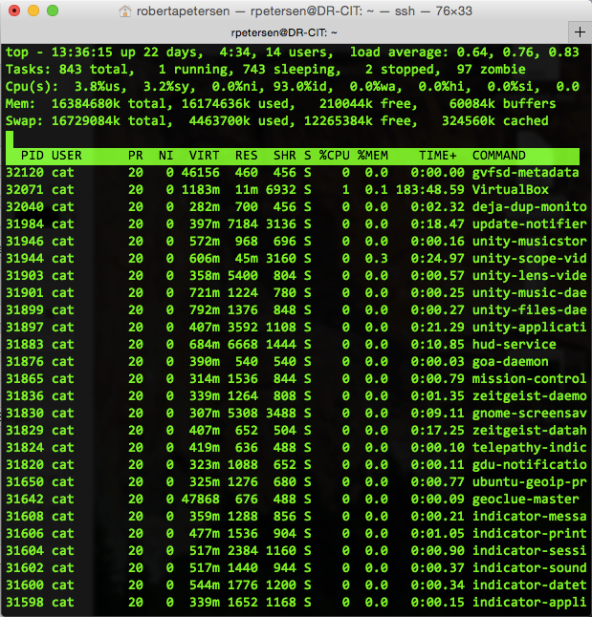
Take a screenshot using JING (you can find help in the Resources area if you are unfamiliar with it). You will be pasting that into this document HERE before sending this to me.

We want to only see certain fields. So press “f”
Remove all the fields except USER, %CPU and %MEM
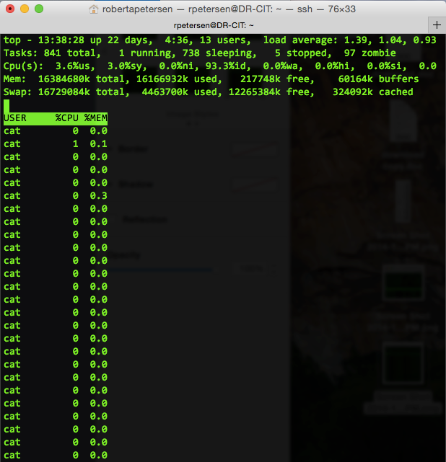
Take a screenshot using JING You will be pasting that into this document HERE before sending this to me.

Press “f” again and this time we want to display the PID and the USER fields only.
Again, when successful take a screenshot and put it HERE.

Press “q” to quit.

Let's see how much processing power the sleep command takes.
Type: sleep 100m&
When we go into top this time we only want to see your processes in top so
Type:
ps -C sleep

We'll use top to find and kill this process. Type:
top -p xxxxx (replace the x's with your PID number for sleep)

To kill the process type k and it will then prompt you for the process id. Kill sleep using it's PID
Type q to leave top

Change into the directory /var/log
Do a long listing and scroll through.
You see red files that end in .gz These are rotated and compressed log files.
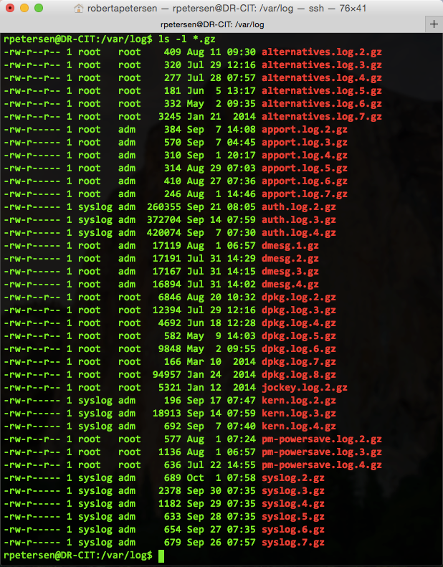
Do a long listing and using a wildcard from last week, display only the files that end is .gz
Take a screenshot of your output and put it here.

Next we want to count those files. Do a long listing, display only those files that end in .gz AND use the pipe to pipe it into word count using the option that only counts lines. See if you can figure it out. The answer is in the Resources area, but test yourself first to see if you can come up with it!

ls -l *.gz | wc -l
39 :-)

